**FILE COMPRESSION**

There are three types in file compression

1. Zip file
2. Gzip file
3. Tar
4. Gun zip file gz -cvzf
5. Bun zip file bz -cvjf

**ZIP**

To create file to be compressed

# **touch file{1..5}.txt**

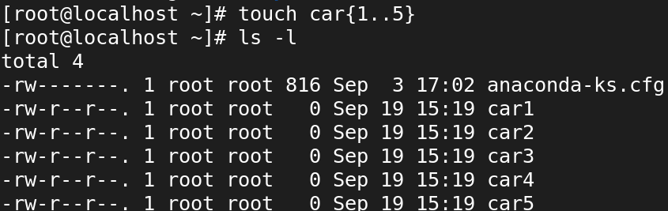

To Create a ZIP Archive

**# zip files file1.txt file2.txt file3.txt file4.txt file5.txt (or) # zip files file\***

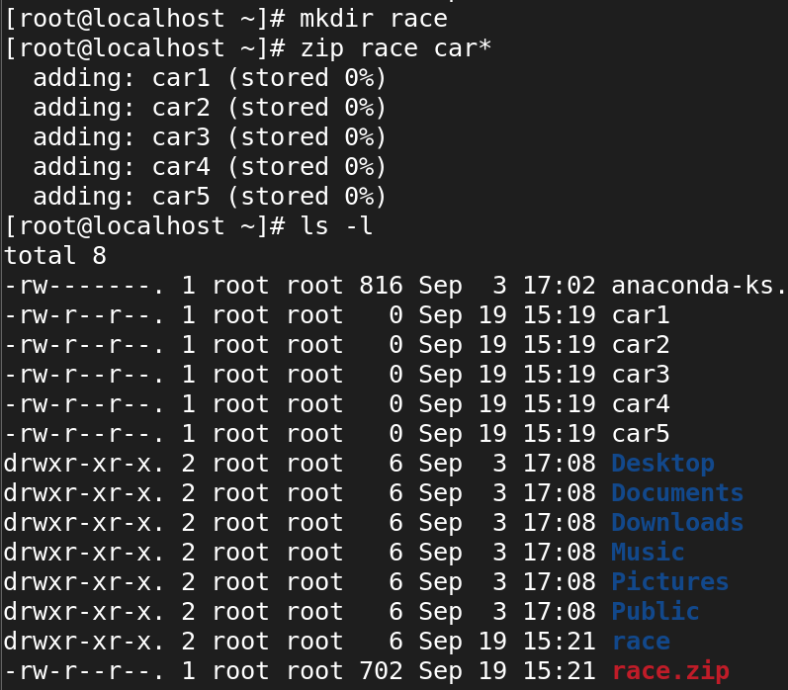

To view zip file

**# zip -sf race.zip**

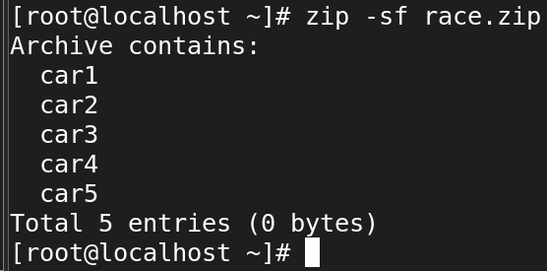

**To allocate storage to file to be compressed**

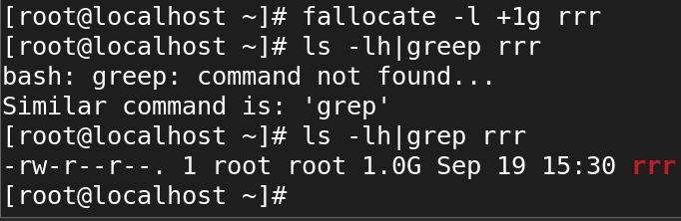

**Zip that allocated file**

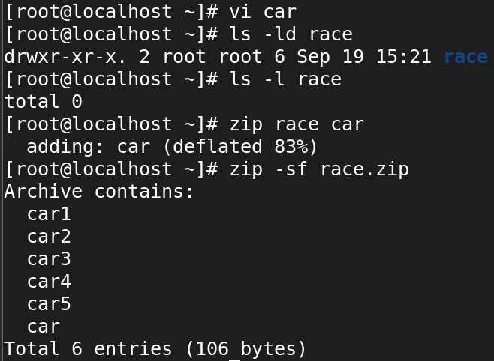

To unzip the zip file

**# unzip filename**

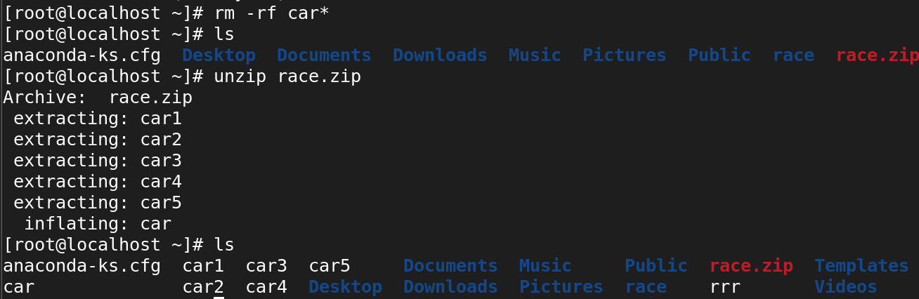

**GZIP**

To create normal file to be compressed

Compressing Files

**# gzip filename**

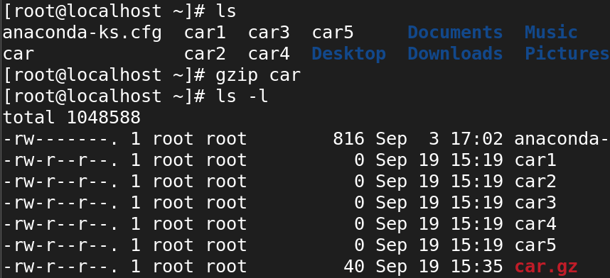

Compress multiple files

**# gzip file1 file2 file3 file4**



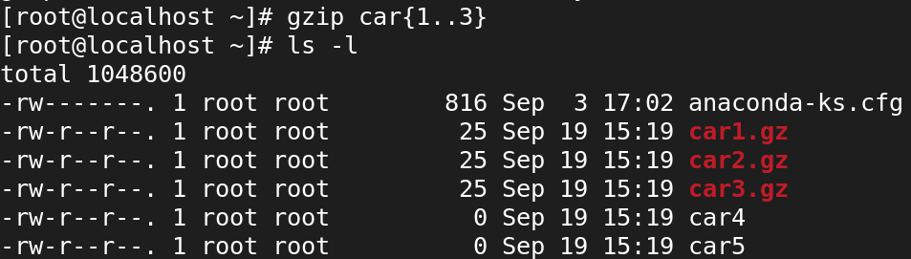

Keep the original file

**# gzip -k filename**

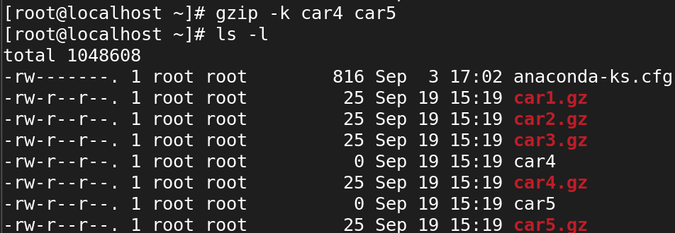

Verbose output

**# gzip -v filename**

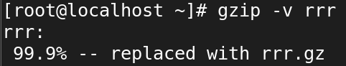

Compress all files in a directory

**# gzip -r directory**

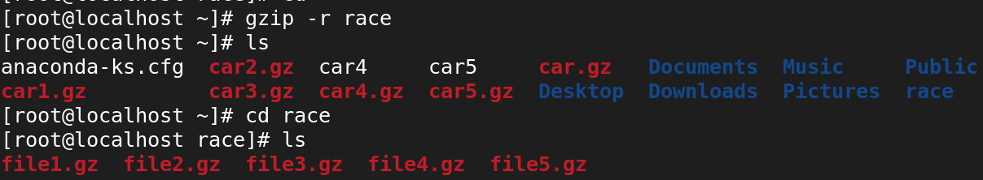

Decompressing Files

**# gzip -d filename.gz**

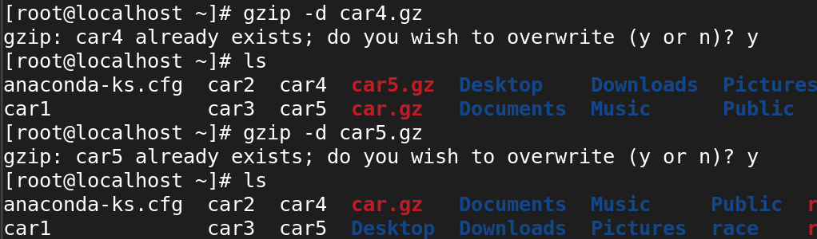

**# gunzip filename.gz**

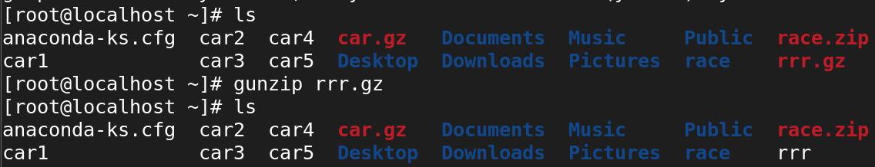

Decompress multiple files

**gzip -d file1.gz file2.gz file3.gz**



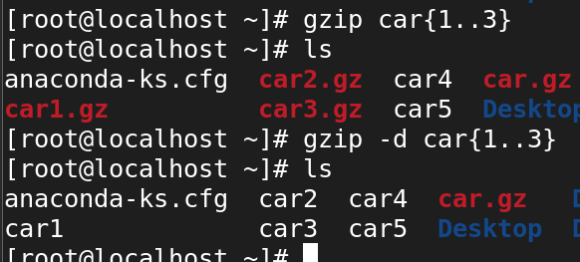

Decompress all files in a directory

**# gzip -dr directory**

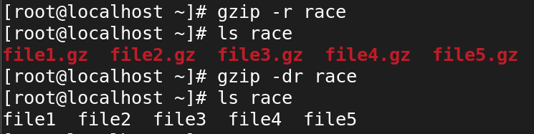

Keep the compressed file

**# gzip -dk filename.gz**

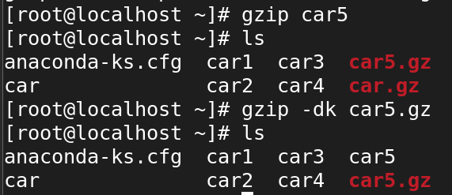

List the Compressed File Contents

**# gzip -l filename**



**# gzip -lv filename**



**TAR**

**Tar means tape archiving**

**1. Create a tar Archive File in Linux**

**tar -cvf etc-backup-14-09-12.tar /etc**

**c – Creates a new .tar archive file.**

**v – Verbosely show the .tar file progress.**

**f – File name type of the archive file.**

**tar -cvf etc-backup-21-08-24.tar /etc**





**2. Create tar.gz Archive File in Linux (Note: tar.gz and tgz both are similar).**

**tar -cvzf etc-backup-14-09-12.tar.gz /etc**



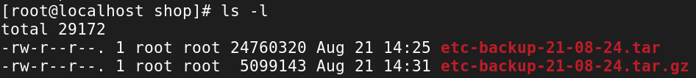

**Create tar.bz2 Archive File in Linux (Note: tar.bz2 and tbz is similar to tb2).**

**tar -cjvf etc-backup.tar.bz2 /etc**



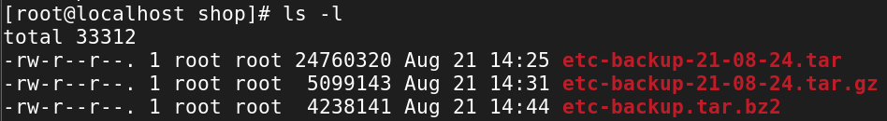

**4. Untar tar Archive File in Linux (tar,tar.gz,tar.bz2)**

**Untar files in Current Directory**

**tar -xvf etc-backup.tar**



**Untar files in specified Directory**

**tar -xvf etc-backup.tar -C /mnt**



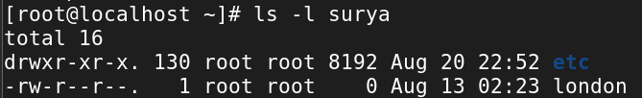

**Untar Single file from tar File in Linux**

**Single file**

**tar -xvf etc-backup.tar passwd group**



**Multiple files from tar, tar.gz, and tar.bz2 File**

**tar -xvf etc-backup.tar "passwd" "group"**



**List Content of tar Archive File in Linux**

**tar -tvf backup.tar**

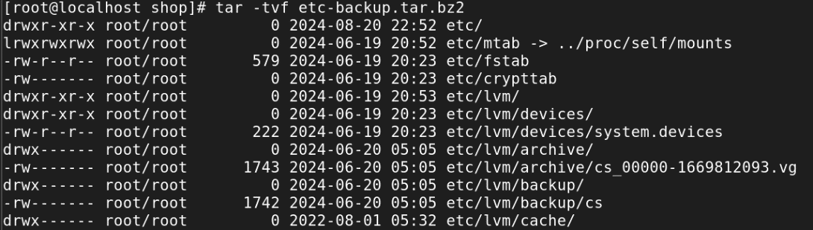

**Add Files or Directories to tar Archive File in Linux**

**tar -rvf backup.tar file1 file2**



**Remove File and Directory from Tar Archive**

**tar --delete -f backup.tar file1.txt**



**tar --delete -f backup.tar '/home/tecmint/uploads'**



**To add and remove file or directory from a tar.gz file in Linux**

**STEPS:**

**1. First we want to extract the .tar.gz file .**

**2. Then copy or move the file or directory to the extracted directory.**

**3. And then recreate your .tar.gz with new file.**

**Here is the output:**

1. 



1. 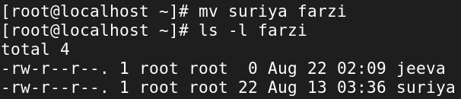
2. 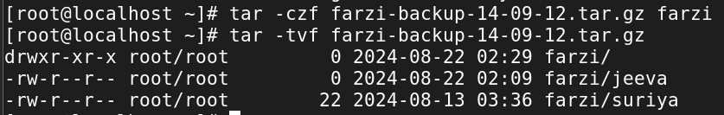

**-uvf ?**